ABC’s LOST and Lord of the Flies
Throughout our five sections of the novel, we will be viewing part of season one of LOST.
There are 5 sections of LOTF in total, and we will be watching LOST after every section except the last.
Compare Jack to Ralph (LOST to LOTF)
Themes: LOST and LOTF
Structure of Society: (LOTF and LOST)
Mysteries on the Island: (LOST and LOTF)

Other Tasks:
Jack from LOST and Ralph from LOFT are not the only characters who have similar personalities. Find two more character matchups and explain how the two different sets of characters share similar traits and purposes in the series and in the novel.
Compare and Contrast LOST with LOTF. What is the same? What is different? Be sure to pay attention to the compare and contrast essay sheets.

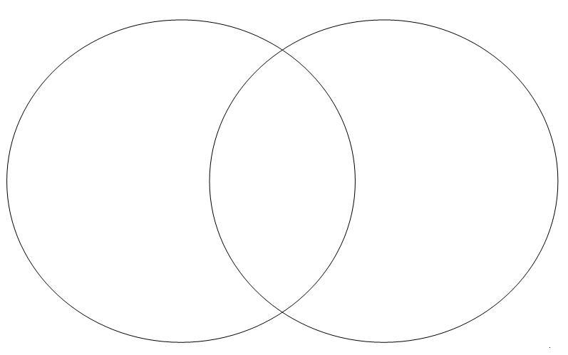
LOST and LOTF: Jack and Ralph
Differences LOST Similarities Differences LOTF

LOST and LOTF: Themes
Differences LOST Similarities Differences LOTF

LOST and LOTF: Structure of Society
Differences LOST Similarities Differences LOTF

LOST and LOTF: Mysteries on the Island
Differences LOST Similarities Differences LOTF

