**ELA 20 Fairytale Fun!!** Name: ____________________________

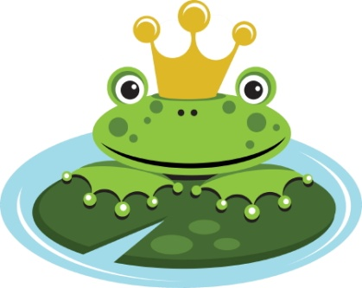

**Fairytale Project**

|  |
| --- |
| For this project you have four options. You can:   * Write an original fairytale * Transport a character from one fairytale into another * Modernize an old fairytale * Write a sequel to a fairytale   For now, choose one and let us spend 3 minutes on it with a free write. Done. Great.  Let us do it again with another topic. 3 minute. Done. Great.  Now, let us share our ideas with others. Sharing our ideas with others is NOT copying. It is using other’s work to make ours better. We will do a simple jigsaw. It will be great. |

For the next week, we will be working on creating our own Fairytales. You will have a lot of freedom as to what your Fairytale will be about. However, there are a few guidelines I want you to follow. They are:

* Using the 10 points from the essay “Who’s Afraid of the Wicked Witch?” your Fairytale must follow at least three of these points. Make sure that your Fairytale does not teach all three of the negative lessons. The three points that your Fairytale teaches must be written down and explained. These must be submitted along with your Fairytale to receive the marks. **20 Marks**
* Your Fairytale should come to life on the storyboard first. After, we will create digital stories with your choice of platform. Tools that we can use are movie maker, and Adobe Spark video. We are not limited to these! If you find something else, you would like to work with then try it.
* Your Fairytale must be appropriate in content.
  1. Would you read it to your younger sibling?
  2. Is the content acceptable for a Catholic school?
  3. Would you read it to your parents in front of Ms. Proch?

**if you have answered no to any of the above questions, change your content.

**This project is due for: November 28th (I will move on in the class prior to this date)**

* C:\Documents and Settings\j.proch\Local Settings\Temporary Internet Files\Content.IE5\X8U5FXG4\MC900116014[1].wmfDigital Story telling layout (mainly for me)
* Discuss what digital storytelling is using the Vaughan Sisters
* Discuss Creative commons and its importance.
* Discuss storyboarding
* Discuss rubric

Please see the attached rubric and storyboard template.