Name: ________________
ELA B30 Proch
Biography of William Blake
William Blake was born in London on November 28, 1757. From early childhood, Blake spoke of having visions—at four he saw God "put his head to the window"; around age nine, while walking through the countryside, he saw a tree filled with angels. His parents observed that he was different from his peers and he learned to read and write at home.
At age ten, Blake expressed a wish to become a painter, so his parents sent him to drawing school. Two years later, Blake began writing poetry. Blake was close with his brother Robert. When Robert died, he believed that Robert's spirit continued to visit him and later claimed that in a dream Robert taught him the printing method that he used in Songs of Innocence and other "illuminated" works.
Blake was extremely talented though he was often labelled an eccentric, insane or demented, due to his visions. His works did not gain much acclaim or commercial success until long after his death. Although he had several patrons over the course of his life and produced voluminous works, he often lived in poverty. Most of Blake’s work consisted of the recurring themes of good and evil, heaven and hell, knowledge and innocence, and external reality versus inner. This is evident in his most popular collections Songs of Innocence, written in 1789 and Songs of Experience written in 1794. William Blake died on August 12, 1827.

“The Poison Tree”
William Blake

I was angry with my friend:
I told my wrath, my wrath did end. Quatrain
I was angry with my foe;
I told it not, my wrath did grow.
And I water'd it in fears, C
Night & morning with my tears; C Rhyme Scheme
And I sunned it with my smiles D
And with soft deceitful wiles. D
And it grew both day and night,
Till it bore an apple bright;
And my foe beheld it shine,
And he knew that it was mine,
And into my garden stole
When the night had veil'd the pole:
In the morning glad I see
My foe outstretch'd beneath the tree

Questions:
1. A Quatrain is a unit or group of four lines of verse.
How many quatrains are in this poem? __________________

2. A Rhyme Scheme is the pattern of rhyming lines in a poem. It is usually referred to by using letters to indicate which lines rhyme.
Put the rhyme scheme of each quatrain here. (I did the second quatrain for you)
1. ______________ 2. CCDD 3. ______________ 4. ___________________

3. Paraphrase what the speaker is saying in the first quatrain.

4. The speakers is comparing his wrath to a plant.
This comparison is a literary device called a ___________________.

5. The foe knows that the apple tree belongs to speaker. So why does the foe think it is ok to eat an apple from this tree?

6. What happens to the foe?

7. Is this what the speaker wanted?

8. What is the theme of this poem? (2)
Theme: - A topic of discourse or discussion;
- A unifying or dominant idea throughout the text

9. Can you think of any other poems, stories, tales, or books this poem may allude to?
Allusion- figure of speech that makes a reference to, or representation of, a place, event, literary work, myth, or work of art, either directly or by implication

/10

Do this before the chimney sweepers

The poem 'A Poison Tree',by William Blake is a emphatic depiction of the consequences of repressed feelings and emotions in human beings. Blake is trying to show how dangerous wrath can be. The wrath the speaker has towards his friend is spoken of and quickly dissappears. However, the wrath towards the enemy does not get released, and it brings with it much negativity. So from this poem we learn that it is always better to express frankly, or to give up if possible, all our hatred and evil notions towards others.
My Notes:
Quatrain one:
-He told his friend that he was angry, and the result was that his anger went away
- When people do not say how they feel, the bad feeling becomes worse
(Easy to understand, so the lesson is easy as well! Rhyme is simplistic show how easy these lessons and morals can be taught and remembered. A purposely easy rhyme)

Quatrain two:
- In these lines, the speaker tells how he has tended and cultivated his anger, how he has made it grow
- uses a metaphor- his wrath stands for a plant- he waters his wrath
- wiles are sly tricks- strategies intended to deceive someone into trusting
-the speaker is laying a trap for his for
- smiles- he is pretending to be friendly to his foe- The false smiles he bestows on his foe act like sunshine on his plant

Quatrain Three:
- emphasizes how consumed the speaker became with his growing hatred of his foe.
- the tree grew and it grew an apple but it’s a poisonous apple
- the foe sees the apple and he sees it shining (beheld- supposed/believed/thought)
- and he knows that the apple belongs to the speaker, but the speaker has tricked him into thinking that he is his friend

Quatrain Four:
- the foe went into the garden (stole- wrap/scarf)
- when the night had uncovered his garden and in the morning he was glad to see his friend stretching up to pick out an apple and eat it.
- (he essentially kills his friend bc his friend ate the poisonous apple)

ELA B30 PROCH
William Blake`s Works A Poison Tree
(1757- 1827) Songs of Experience
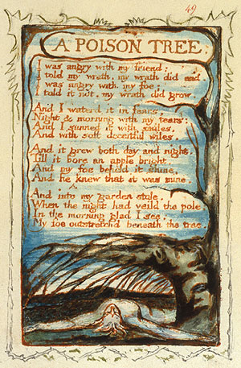
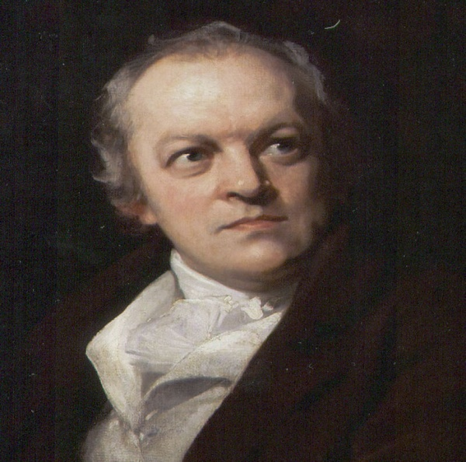

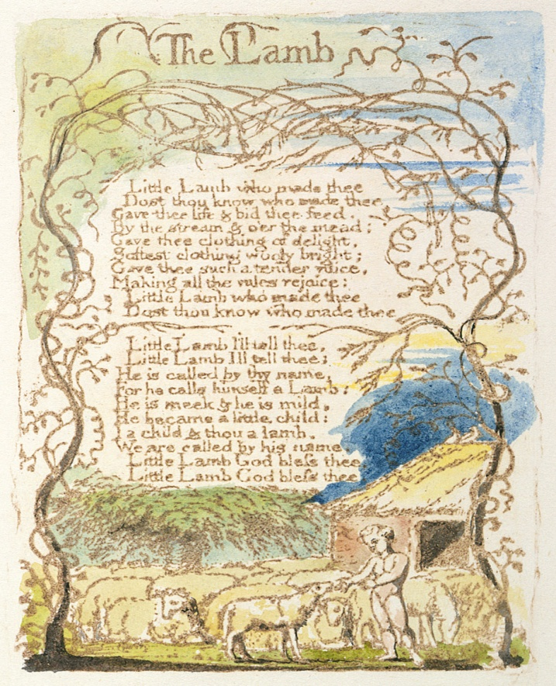
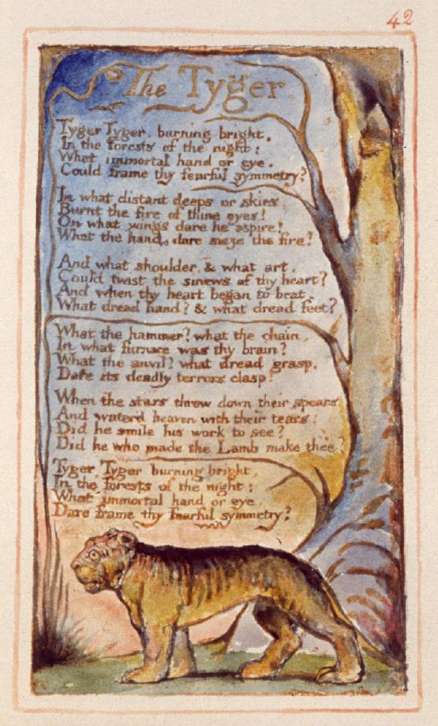

The Lamb The Tyger
Songs of Innocence Songs of Experience

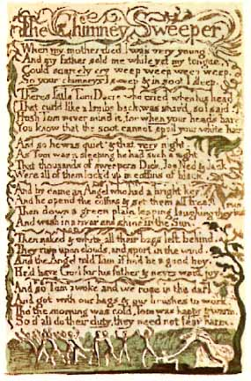
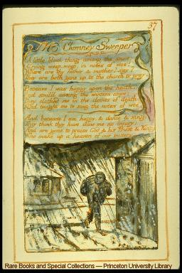
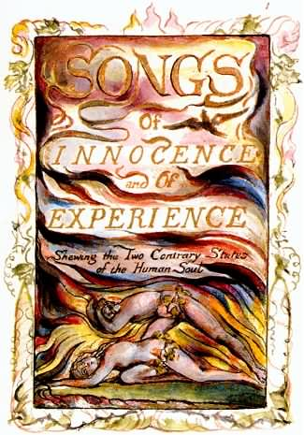
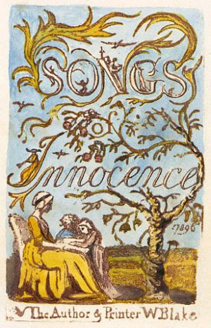
Songs of Innocence (1789) Songs of Experience (1794)

The Chimney Sweeper The Chimney Sweeper
Songs of Innocence Songs of Experience

