Name: _____________
ELA B30 Proch
John Keats Biography
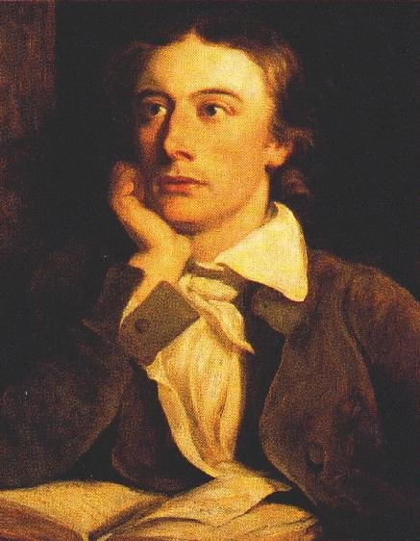
John Keats only wrote poetry for three years, but he was known for expressing beauty and the use of elaborate words and sensual imagery. He was the last of the romantics.
John Keats was born in London on October 17, 1795. His father died when he was eight and his mother died when he was fourteen. Sadly, his mother, brother and good friend all died for tuberculosis.
In 1818, Keats became ill with tuberculosis. During this time, he met Francis (Fanny) Brawne. She nursed him when he was ill and he fell in love with her. The sonnet we are learning about may have been inspired by his relationship with her and his perception of his imminent death. He passed away in February of 1821.

When I Have Fears That I May Cease to Be

When I have fears that I may cease to be
Before my pen has glean'd my teeming brain,
Before high- piled books, in charact'ry,
Hold like rich garners the full-ripen'd grain;
When I behold, upon the night's starr'd face, | 5
Huge cloudy symbols of a high romance,
And feel that I may never live to trace
Their shadows, with the magic hand of chance;
And when I feel, fair creature of an hour!
That I shall never look upon thee more, | 10
Never have relish in the faery power
Of unreflecting love;—then on the shore
Of the wide world I stand alone, and think,
Till Love and Fame to nothingness do sink.

Tell me what you know: (10)

In order to answer this questions, break it up into various parts. Perhaps you want to think about TPCASTT or break it up into rhyme, rhythm, meter, connotation, theme, literary terms etc. Think about my lecture.
Be specific as possible.

John Keats Lecture

You could think of John Keats as the Heath Ledger of his time: famous, talented, and destined to die far, far too young. In fact, Keats was only 25 when he died in 1821. Like Ledger, Keats cut a pretty dashing figure. The ladies swooned for him. Heck, the men swooned for him, too. When he died at the tender young age of 25, he had already penned poems and letters that would become the cornerstones of the Romantic movement.
Unlike Heath Ledger, Keats was pretty morbidly fascinated with the thought of his own demise. See, he spent most of his youth and adulthood suffering from tuberculosis, a disease that brought him into frequent contact with the possibility of death. Keats was a totalRomantic. That's Romantic with a big "R" – this describes a group of writers kicking around in the 1800s. Like his Romantic buddies, he was a big fan of huge, sweeping, mind-blowing emotion. Keats managed to ratchet up that emotion by adding in a huge dose of mortality to most of his works. Life, you see, is fleeting.

If you read "When I have fears that I may cease to be," you'll find a prime example of just this sort of mentality. Written in 1818, the poem was originally enclosed in a letter to John Hamilton Reynolds, Keats' BFF. The poem's practically a primer for Keats' own psyche. It lays on the line his desperate desire for love and success. It also shows his certainty that he'll die before they come his way. Sure, it's a little morbid – but it's also ridiculously good.

Keats' speaker contemplates all of the things that he wants in life: namely, success, fame, and love.
his poem charts both the speaker's desires and his despair (in that order). Come to think of it, the poem doesn't exactly end on a happy note.

Gleaned- exract
Teemed- full of
- Here's the rough translation: If I die before I have written lots of books (that's the "high piled books," in case you were wondering) which hold my words like a grain silo (that's the "garner") holds ripe grain…

- Speaker gets caught up in tumultuous, overwhelming, passionate desires.
- Speaker goes off alone to contemplate nature.
- Speaker realizes that all his/her desires are petty and small – especially when they're compared to the scope of the outside world.
Sonnet iambic pentameter,
Turn!

